Civics and Citizenship

Key Concepts

Democracy

- What is the meaning of the word democracy?
  - Demos (people)
  - Kratos (rule)
  - Dictate (ruled)
  - A and B combined

- Where did direct democracy first get its start?
  - Athens
  - Rome
  - Washington D.C
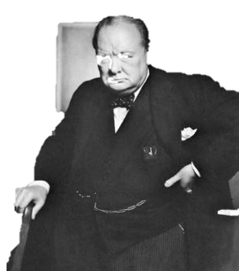
  - Persia

- Which of the following groups were allowed to vote Athens?
  - Slaves
  - Women
  - Landowners
  - Children

- Which of the following is not a part of an indirect democracy?
  - You vote for the people who become law makers.
  - You can't vote for a new law yourself.
  - A and B
  - None of the above.

‘… it has been said that democracy is the worst form of Government except for all those other forms that have been tried from time to time.…’
Winston S Churchill, 11 November 1947

Democratic Values
Democratic values are the shared values of Australian citizenship such as equality, tolerance, freedom and the common good.
- The table below lists some of Australia’s values, connect the value to its definition.
Australian Values |  | Definition
Respect |  | All people are treated fairly, or without in justice, and are given equal opportunity. Also known as a ‘fair go’ in Australia.
Equality |  | Rights and privileges for all, without discrimination based on gender, race, religion, age, sexual orientation or level of educations. All citizens have the right to same opportunities.
Fairness |  | Rights, privileges and responsibilities for all without interference, or control from other citizens or government.
Freedom |  | Treating others with consideration and valuing their view, beliefs and rights

- What are our school’s core values?

The Westminster System
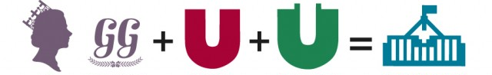
- Identify the components of the Westminster System in Australia:

Justice
- Use the words from the PowerPoint to complete this paragraph:
The idea of justice can mean different things to people from different __ __ __ __ __ __ __ __ __ and __ __ __ __ __ __ __ __ ; for some it might mean __ __ __ __ __ __ __ , while for others it might mean __ __ __ __ __ __ __ __ . However, the concept of justice in Australia ultimately means that people should treat each other in a way that is fair and balanced.

Participation
The concept of participation is an important part of living in a democracy. It refers to the way good citizens contribute to or take part in society. In Australia we participate in the running of society in a number of ways such as by voting in an election or referendum, serving on a jury or paying taxes.
- As you are not yet old enough to vote, what other ways can you participate in Australia’s democratic society?

Rights and Responsibilities
- Children’s rights come with responsibilities, just like adult members of our society. A child’s rights end where the rights of another child or an adult begin. This means that our rights have limits, we must consider the rights of other children and adults when we are exercising our rights.

Write in your responsibilities next to your rights in the table below:

Rights | Responsibilities
to elect representatives to the school’s student council
to education
to health services

Bibliography
Conti, L. et al., 2017. In: Oxford Big Ideas: Humanities and social sciences 8 Western Australian curriculum. Melbourne: Oxford University Press.
Conti, L. et al., 2017. Oxford Big Ideas; Humanities and social sciences 10 Western Australian Curriculum. Melbourne: Oxford University Press. Parliamentary Education Office, n.d. Teach our Parliament. [Online] Available at: https://peo.gov.au/teach-our-parliament/
Zimmer, C., n.d.. Democracy - A short introduction. [Online] Available at: https://ed.ted.com/best_of_web/RgaIhs2w#review

